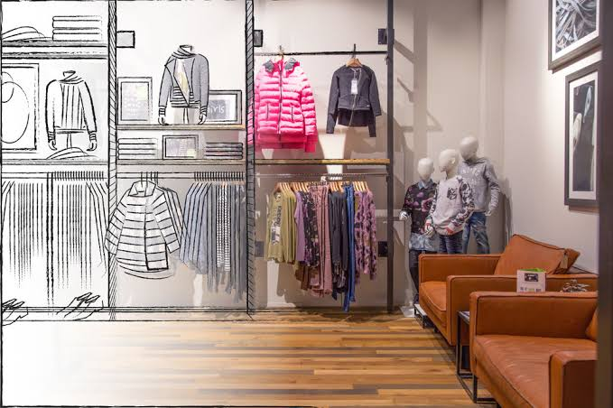

**User Manual of Merchandising Module (Prottay)**

***Table of Content:***

***Page***

I. Work Flow for Merchandising Module …………………………………………………………………………………………………. 3

II. Menu of Merchandising Module ………………………………………………………………………………………………….……… 4

III. Style Creation………………………………. ………………………………………………………………………………………….………..… 5

IV. Style samples……………………………………………………………………………………………………………………………..……..… 6

V. Material Consumptions & RND Info………………………………………………………………………………………………………. 7

VI. Cost & Budget………………………………………………………………………………………………………………………………….…. 8-9

VII. Order Processing…………………………………………………………………………………………………………………………….… 10-11

VIII. Time & Action (TnA)………………………………………………………………………………………………………………….…... 12-13

IX. Bill of Material (BOM)………………………………………………………………………………………………………………………. 14-15

X. Costing (Pre-costing) ……………….…………………………………………………………………………………………………………. 16

XI. Supplier Work Order (Single PO) ………………………………………………………………………………………………………… 17

XII. Supplier Work Order (Multiple PO) …………………………………………………………………………………………..……… 18-19

***User Manual of Merchandising Module***

For the user manual of the merchandising module, Users have to follow those steps. Which is given below.

**Style Sample, Material Consumption**

**Style Development**

**RND**

**Cost & Budget**

**Sample info**

**Add Order**

**Time & Action**

**Bill of Materials**

**Pre costing**

**Work order**

First Click on the Merchandising Module. When the user clicks on the merchandising module then merchandising module will be open.

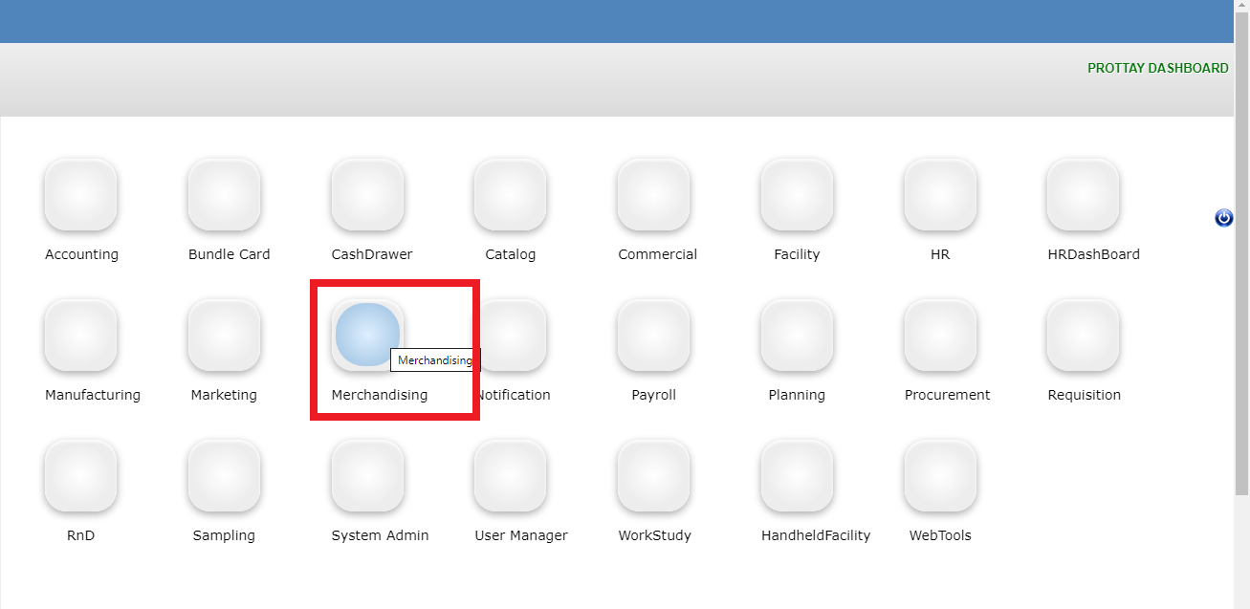

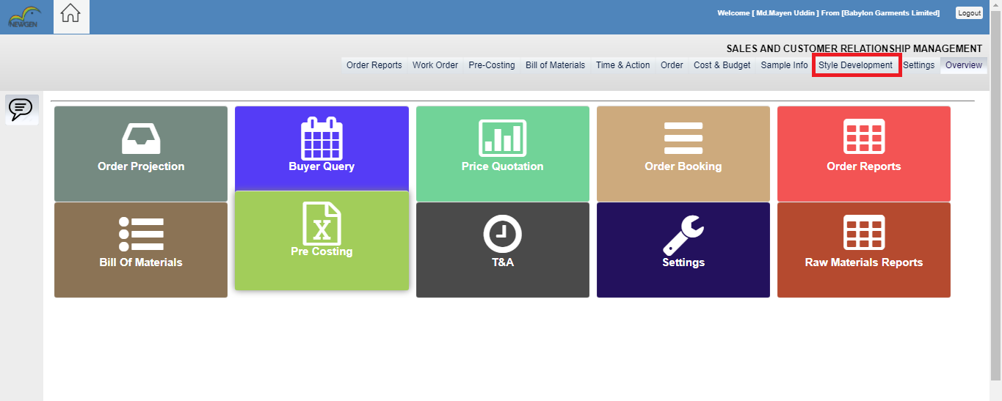

When the user clicks on the style development menu then the user will get two choices. One is user can search old style which is already developed and another one is user can create a new style. If the user wants to search an old style, then user can search by date (from date to thru date). Users can also search by style name, Buyer name, merchandiser name.

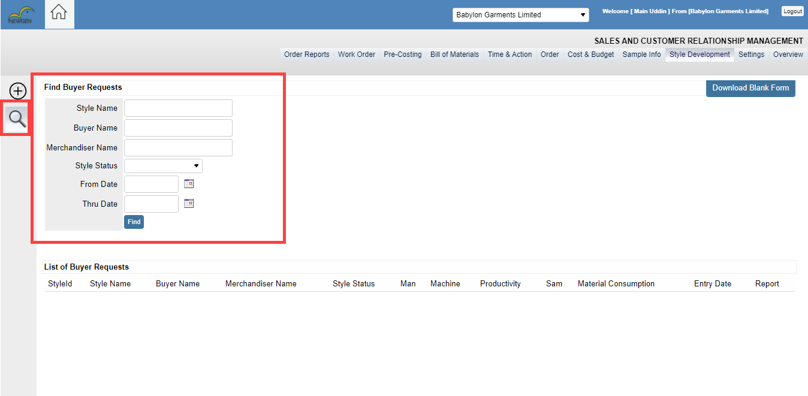

If a user wants to create a new style, then the user has to click on the Icon. After a click, on this Icon user will get a form to create a style development. Where the User needs to fill up the form with the required information.

* Then the Required Form needs to be filled up. In this form **Style Name,** **Buyer Name** and **Merchandiser Name** have to be inserted. **Buyer** and **Merchandiser** Name has to be selected form dropdown. The Product Type has to be selected & insert **quantity**. Then in **Size Range** Column have to be inserted which will come from the dropdown.
* Then **Additional sewing** has to be inserted. After that season has to be selected which will be appeared in the dropdown. The Style status box will be in the **development** stage.

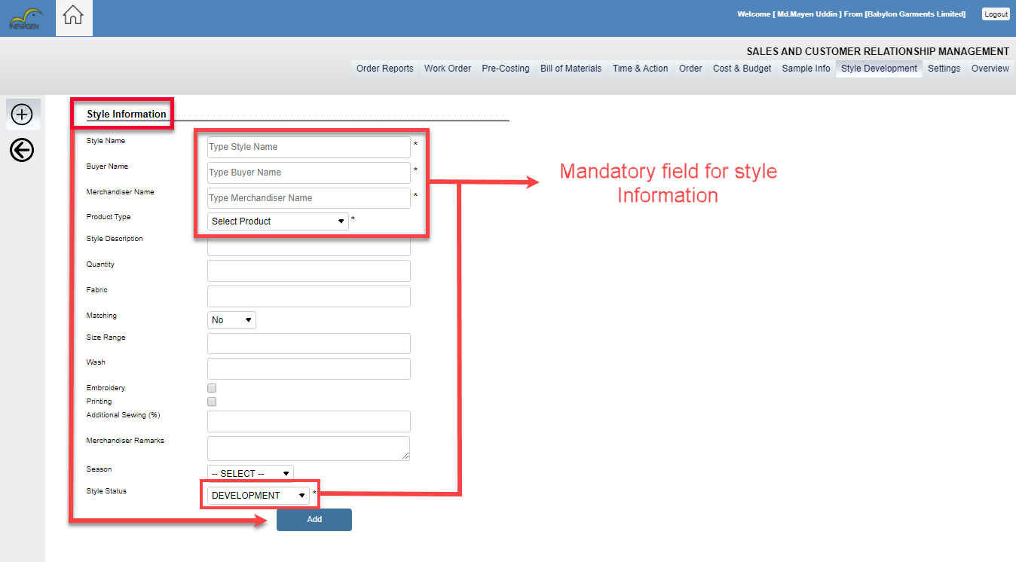When the user fully fills up his style information then click on the add button. After clicking on the add button

Users will get a form where some fields will be generated. Which are style samples, Material list for consumption, R&D History.

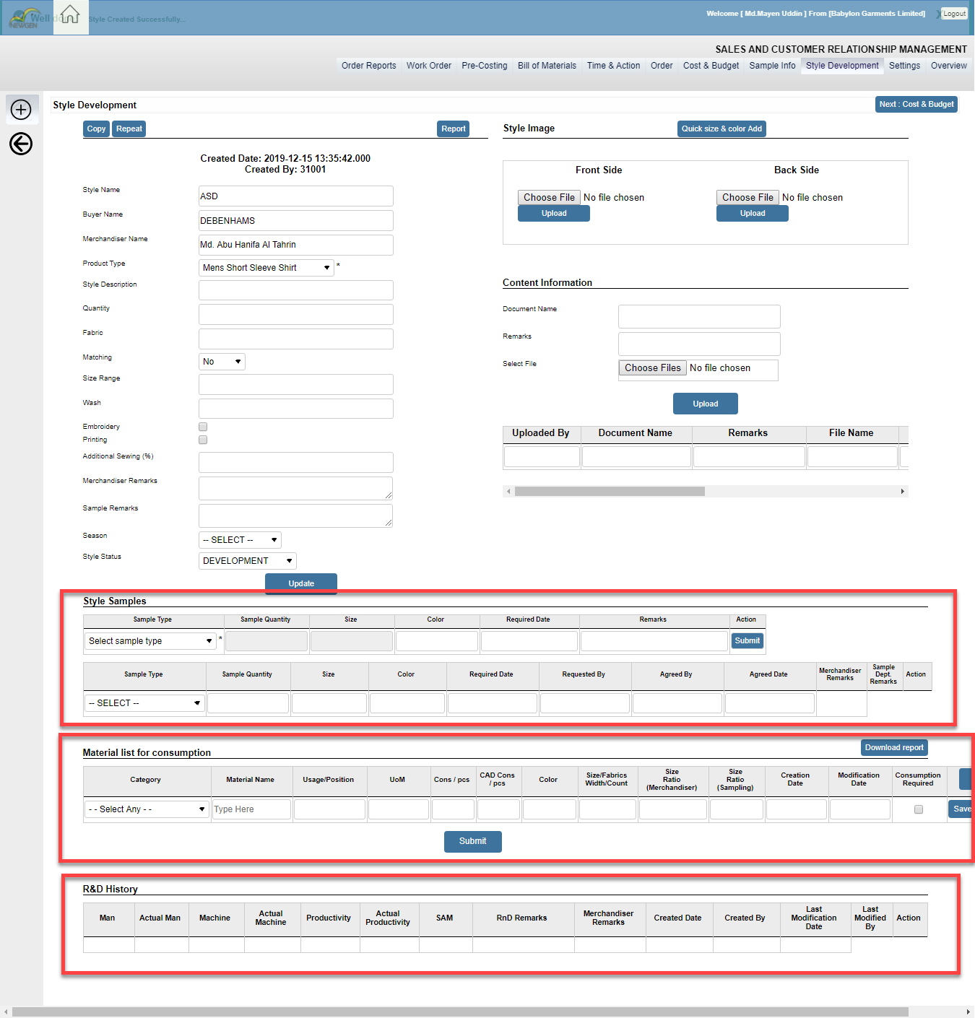

**Style samples:**

Then in style samples, **Sample Type, Sample quantity, Size, Color, and Required date** have to be Filled up and Click submit. Users can add as many samples as required. Merchandiser can input their remarks.

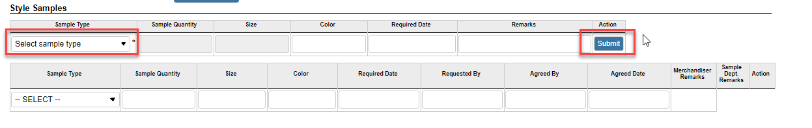 **Sample Style<Sample quantity<Size<Color<Required date**

**Material list of Consumption:**

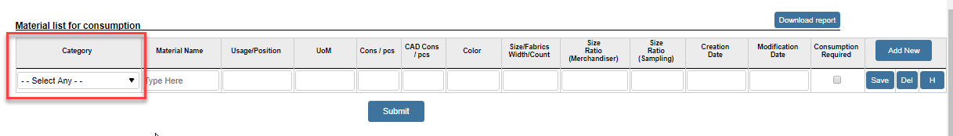Then in the Material list of Consumption part users have to Fill up some of the fields **Category, Material Name, Usage/Position, UoM, Color etc.** have to be Inserted. All of the column information will come from the dropdown. Then in the Consumption required box, users have to fill up the Symbol and click submit. Users can add as many Materials as required.

In the RND section, Merchandiser can only view the data. Rnd expert will include Man, Actual Man, Machine, Actual Machine, Productivity, Actual Productivity, SAM, data from the RND module.

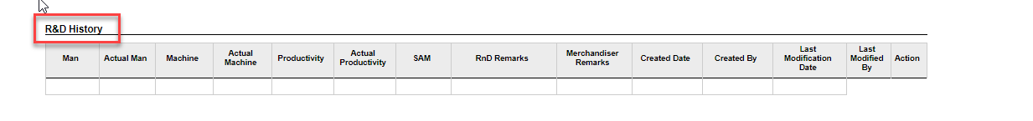

So, after completing the style development section then merchandiser clicks on the next step Cost and Budget section.

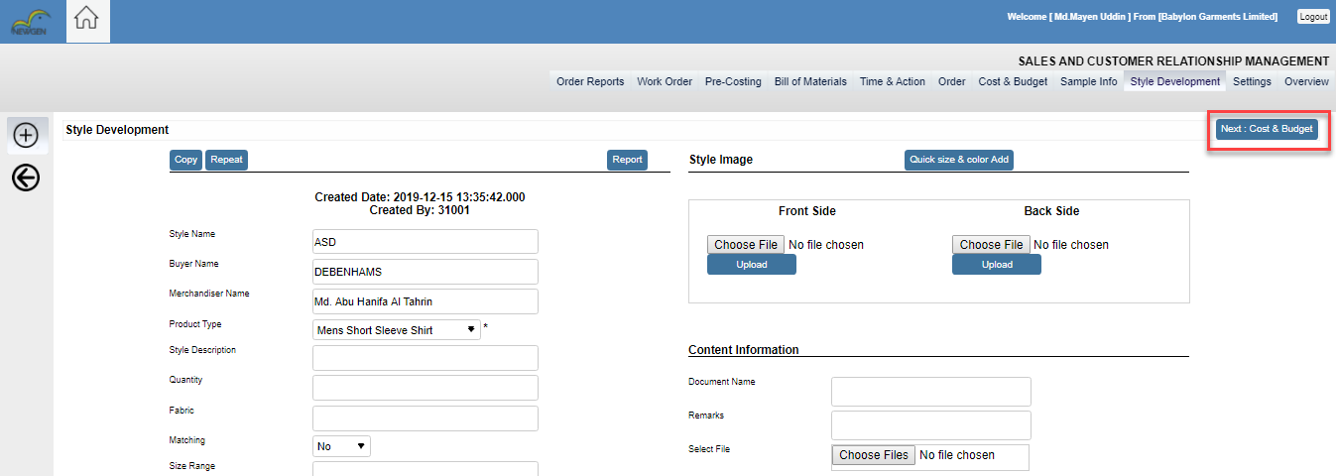

In the Cost and budget section Merchandiser include cost and budget against the material list. Merchandiser also can view style information where all other information will be. Like the below screenshot. In the Cost and budget section user also can view Account Info and Cost & Summery of the material.

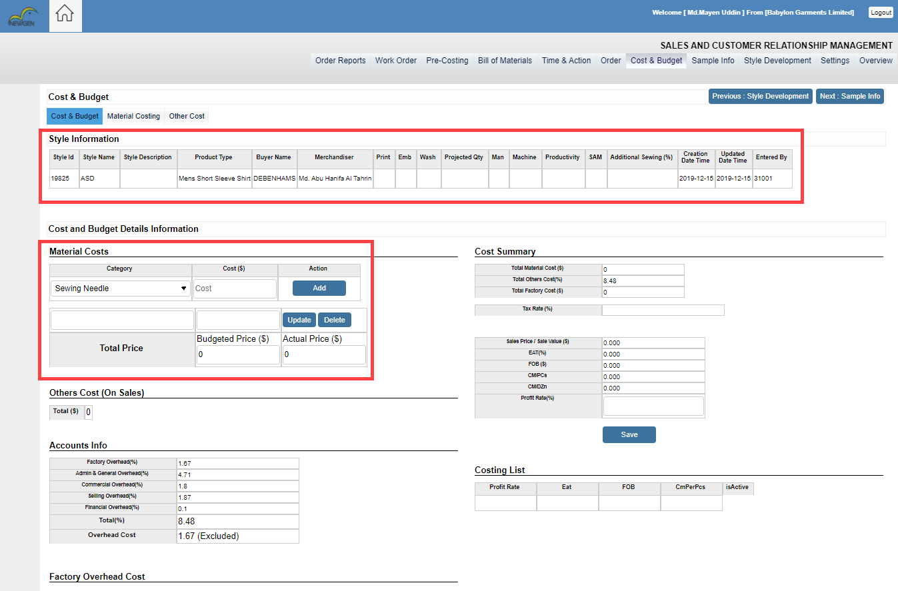

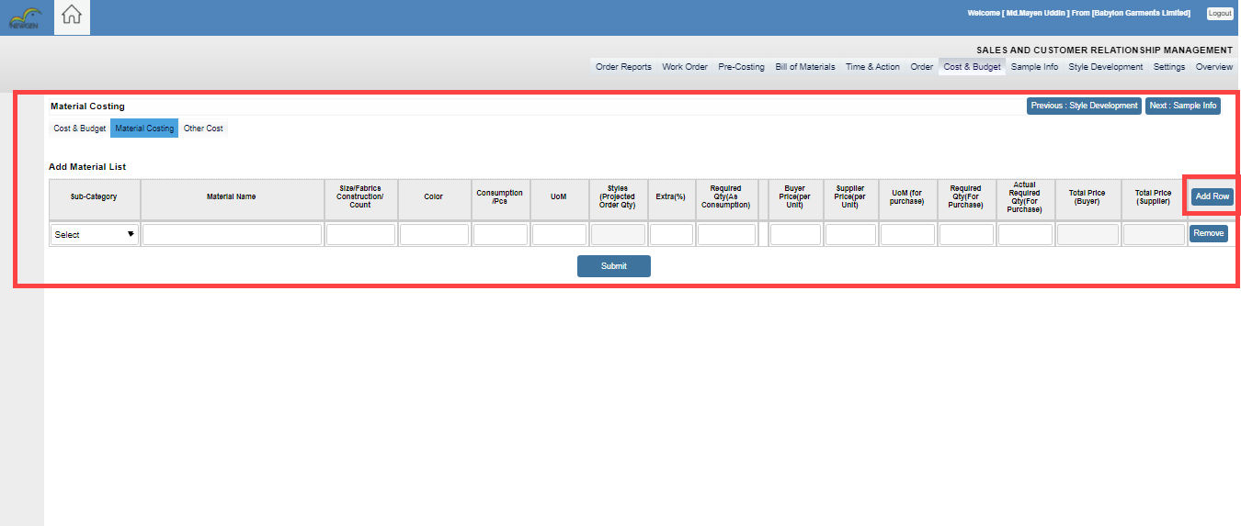When Merchandiser included material Cost then he will go the next part of the cost and budget section that is material costing. In material costing a merchandiser can include more material by clicking the add row button. After getting samples information from the sample department and RND information from the RND department then Sometimes the merchandiser thinks he needs more material, so he can input extra material in this section. In material costing portion, merchandiser finds all material list which he added in style development stage.

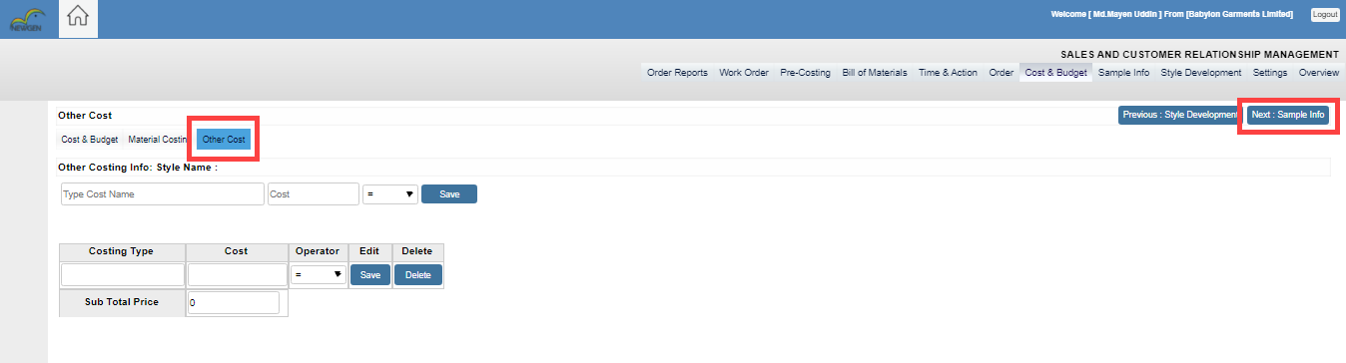When merchandiser complete material costing part then he goes other costs. In this part the merchandiser can add some costs. After completing the Cost and budget section merchandiser will click on the next step sample info.

In the sample info section, Merchandiser can view all data like sampling remarks history that has come from the sample department. Before Adding order merchandiser must check his style status confirmed or not. If the style is not confirmed, then he can’t add the order process. Another thing is the planner must be set the monthly projection quantity otherwise merchandiser can’t create an order. So, if the style is confirmed and monthly projection quantity fixed then the merchandiser goes the next step Add Order

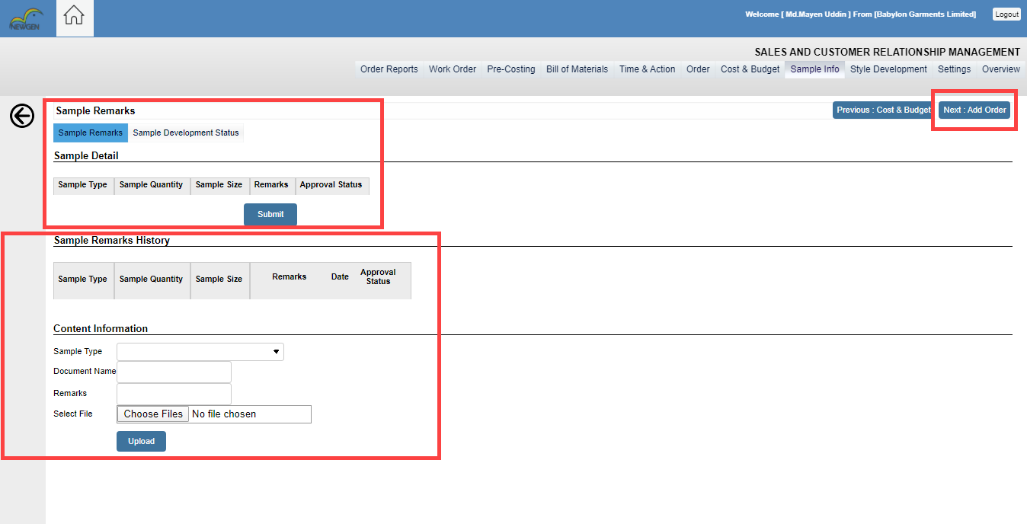

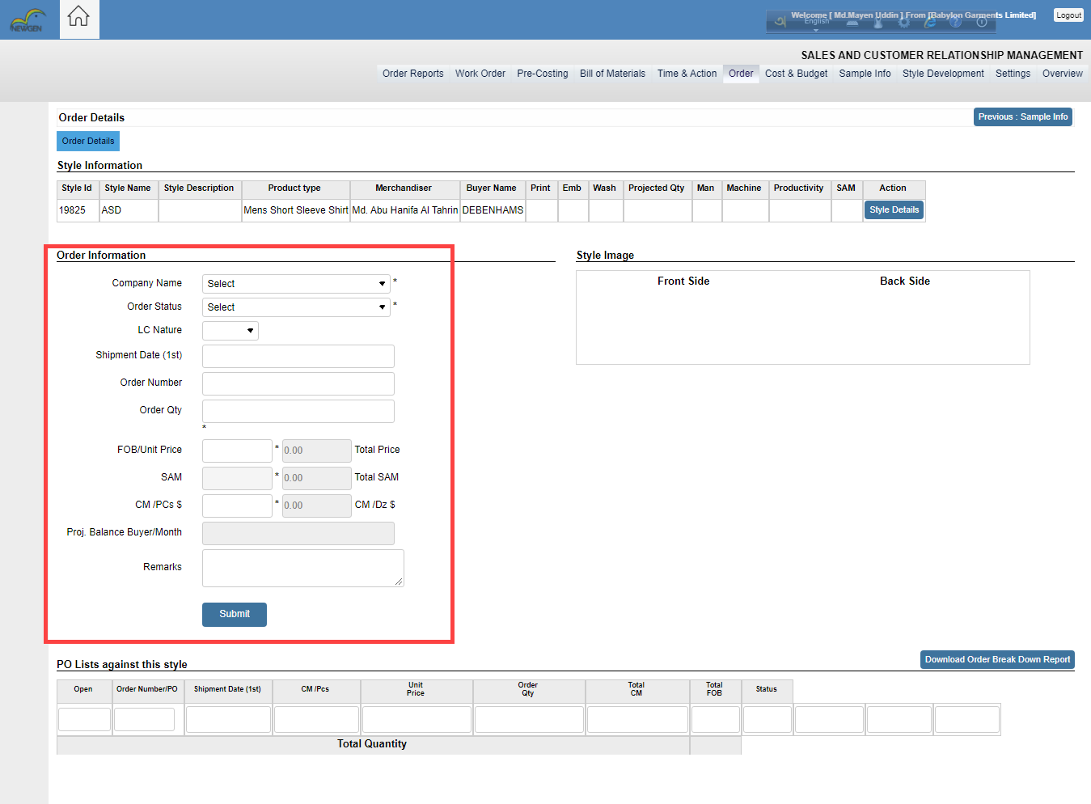 Now merchandiser fills up the order information where order shipment date, order number, final order quantity, LC Nature, Order status are put by merchandiser and click on the submit button.

After created an order, merchandiser needs to move on Order breakdown process. In order breakdown process an order breaks into different sizes. All sizes are come from dropdown. But remember one things, when the merchandiser sets different sizes then he should click on the Save button. Those size are created after selecting the option in the save button.

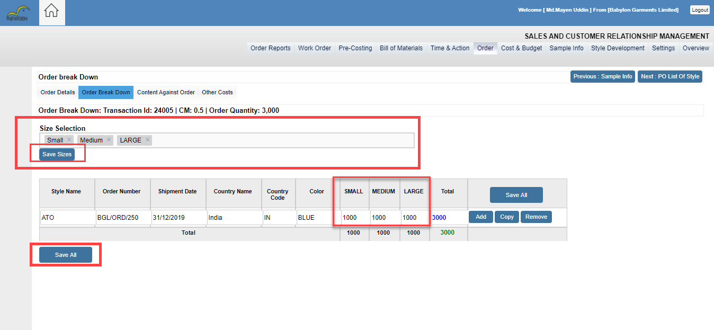

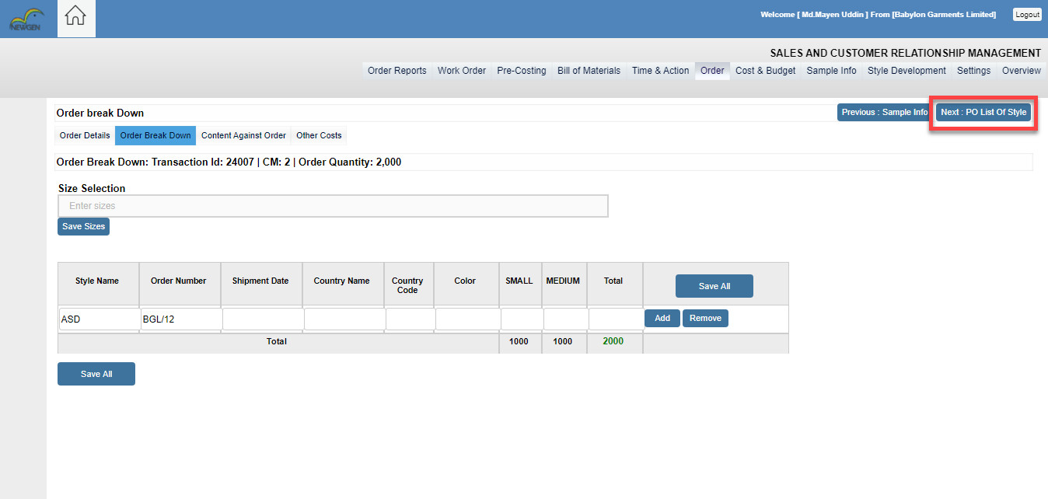After Completing order breakdown, the user clicks on the next step PO List of style.

When the user clicks on the PO list of style then the PO list will be shown with the TnA & BOM .  
In this portion, user can re-open the style by click on the open button. For the TnA information users need to click on the TnA button.

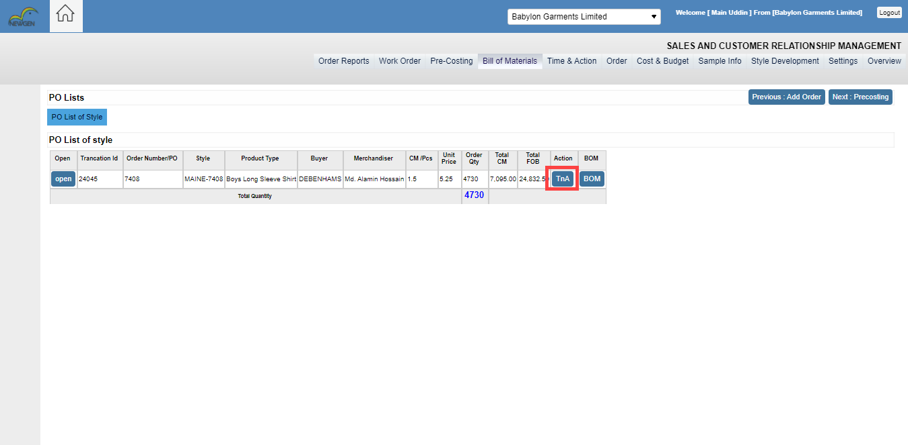

When users click on the TnA button then User will get Template Configuration. In Template Configuration users will get the order summary information. Users have to fill up ORDER CONFIRMATION date and EX FACTORY date. Then the system will calculate the lead time(day). After getting the lead time users has to select AES or DES from the dropdown menu in the event position type.

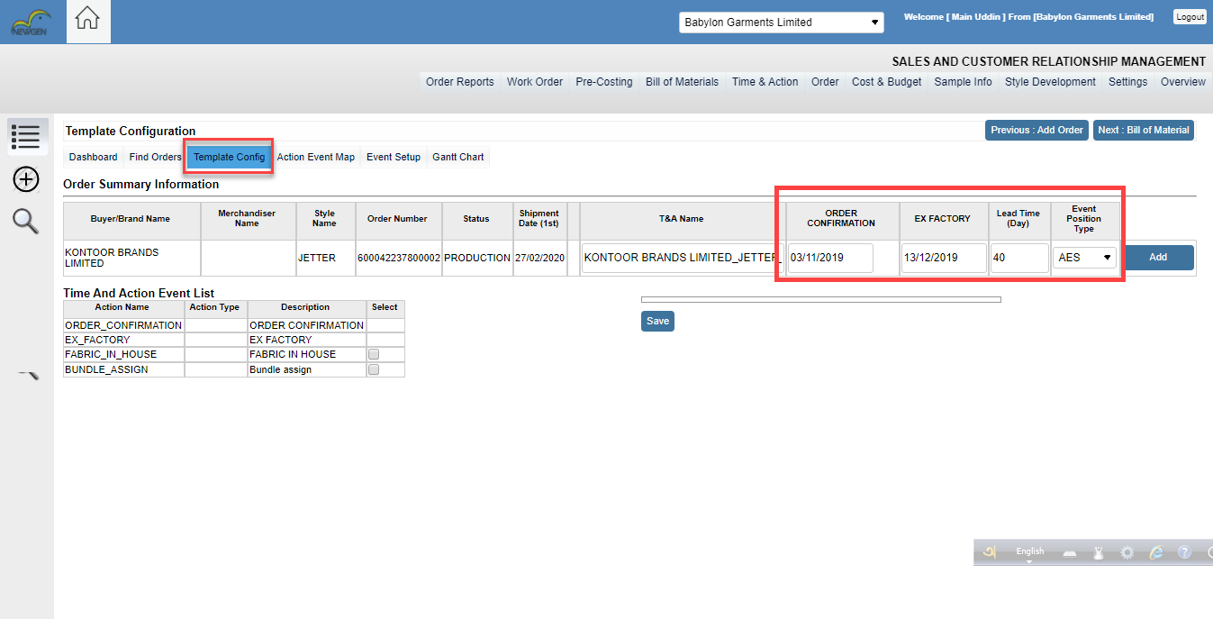

In the Time and Action Event List, user can see Action name > Action Type > Description. In this list user can select Action name. when users select Action name from the event list then the system will generate a small view with the Action name. As like below screenshot. where user can drag and drop Action name and in this screen user have to input the day’s number to start the plan. If the users, select AES from the Event position type then days will be count from the order confirmation date. Otherwise it will be count backward from the EX-FACTORY date. Then click on save button. After click on the save button user get TnA Calendar.

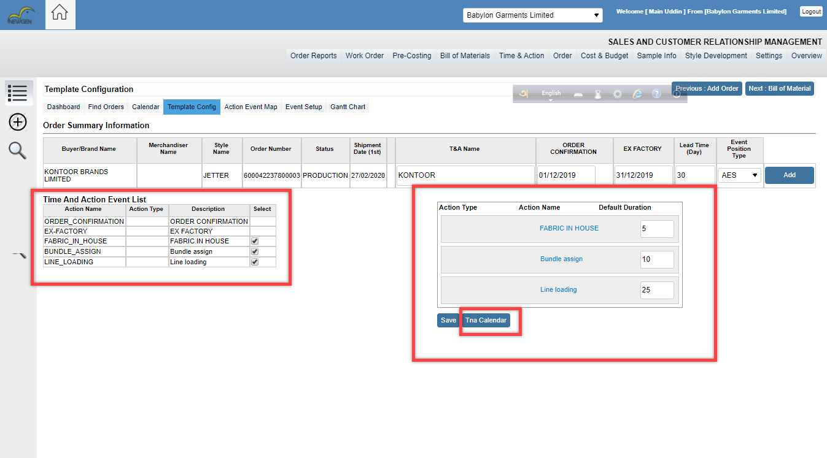

When user click on the “TnA calendar” button then user will get a preview screen where user have to input planned date. If user want to Revised a date, then he can edit revised date with a remarks. Then click on the submit button.

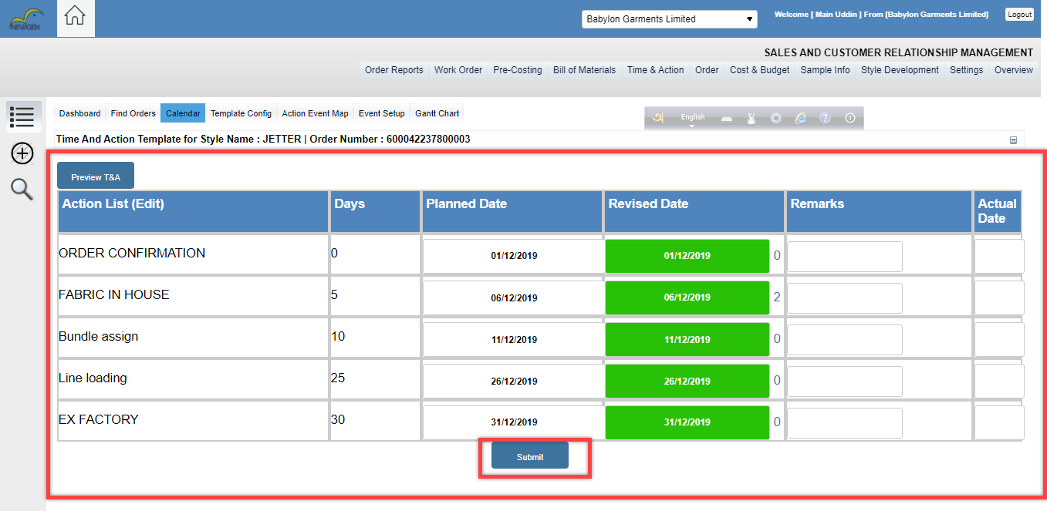

If merchandiser need more T&A Actions, he can create new Actions. For the setup Actions users need to click on this icon and users have fill-up Action name and Event Position, Event type have to select from the dropdown menus. For the Event position user can select start or end. If user select start, then it will be count from the order confirmation date. If user select end, then it will be count from the backward of EX-FACTORY date. User also have to input default Duration. Then click on save button. When users click on the save button then the Action will be created.

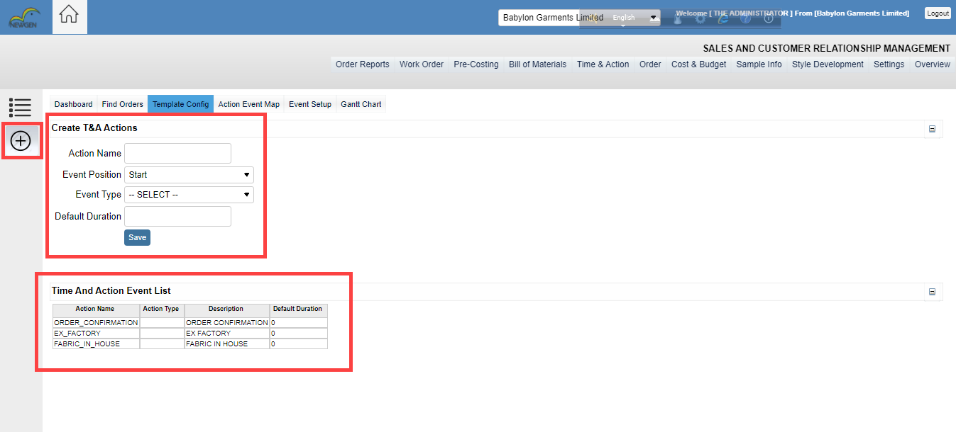

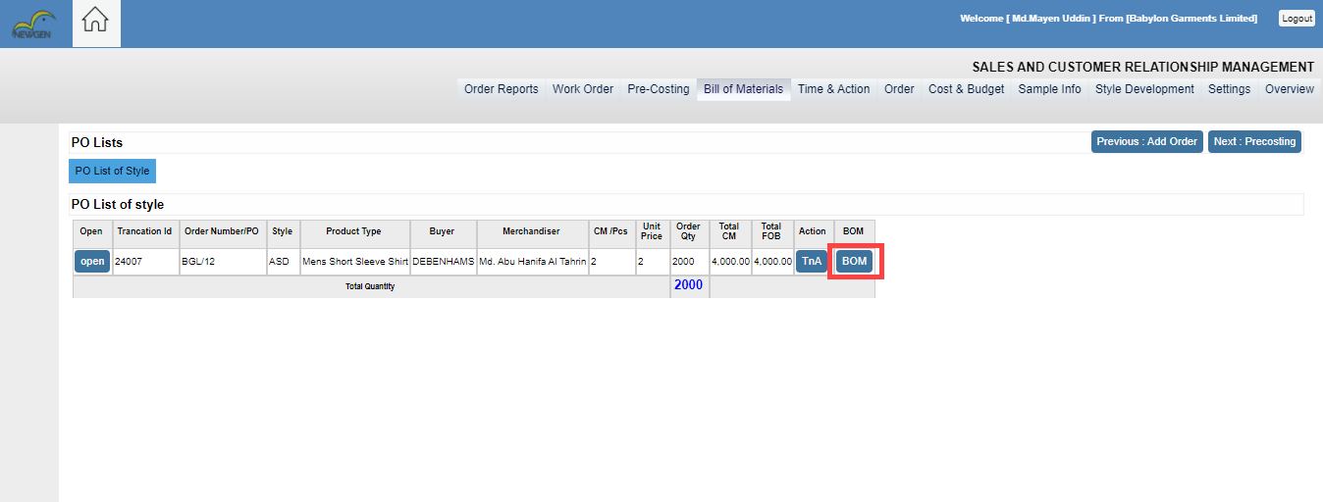After Completing the TnA, Users have to Click on the BOM button. where user will get bill of materials.

When the user clicks on the BOM then material costing will be shown. In this part, the user can add more material by click on the add row button. In Bill of material, Users will get specific knowledge about material costing.

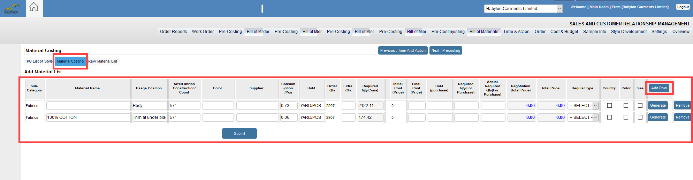

In Material costing user can input materials with different country, color and sizes. If the merchandiser wants to input country wise entry, then he selects country from the checkbox and click the generate button. User also have to select Regular type from the dropdown menu and finally click on submit button.

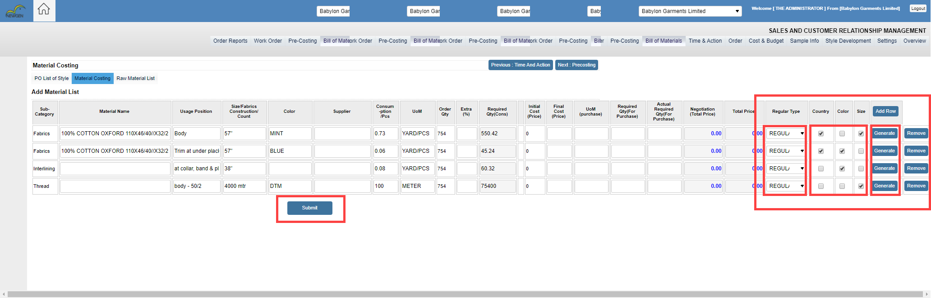

When the user clicks on the next processing step then the user gets Raw Material List. In the Raw Material List, user can see those material names which he added in the BOM list. The user also can remove or copy materials. If the BOM sheet is confirmed, then select Complete from BOM Status and click on the Set button. Otherwise, users can select Canceled, draft, postponed. Raw material list must be saved by clicking ‘’Save All’’ button. now If the user thinks that his raw material is perfectly complete then he clicks on the next processing.

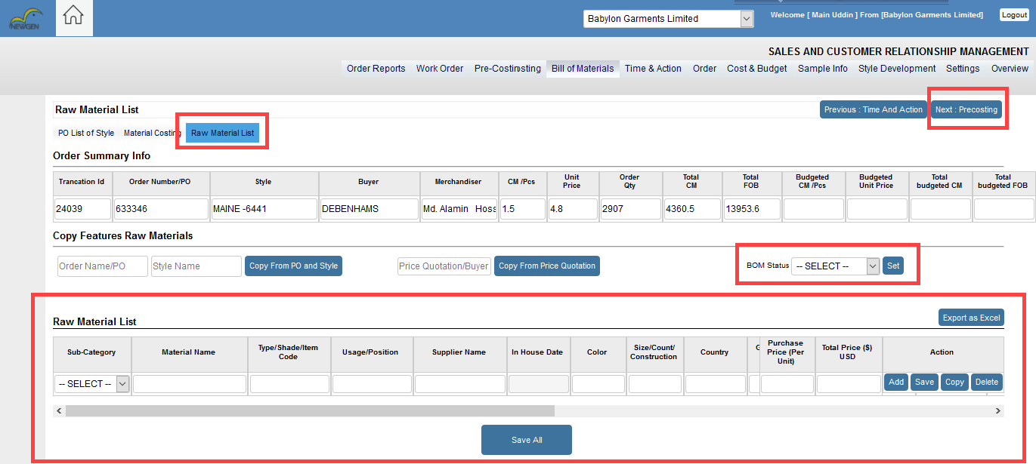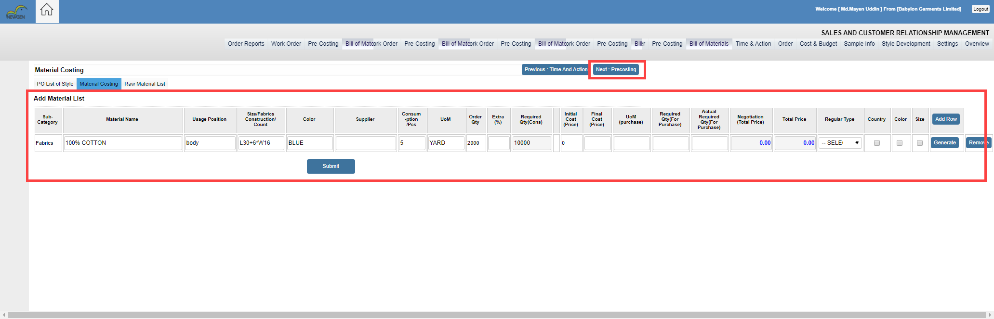

In the Pre-Costing Step, Users can see style name > Buyer Name > Merchandiser Name > Additional sewing > Man >machine > Productivity> Sam. And users also can see style creation date and Updated date time. In pre-costing, Users will get a pre-costing report of that style. For this report user have to click on Report button. In this report user will get details of order information > Productivity > Total cost > Direct Expenses.

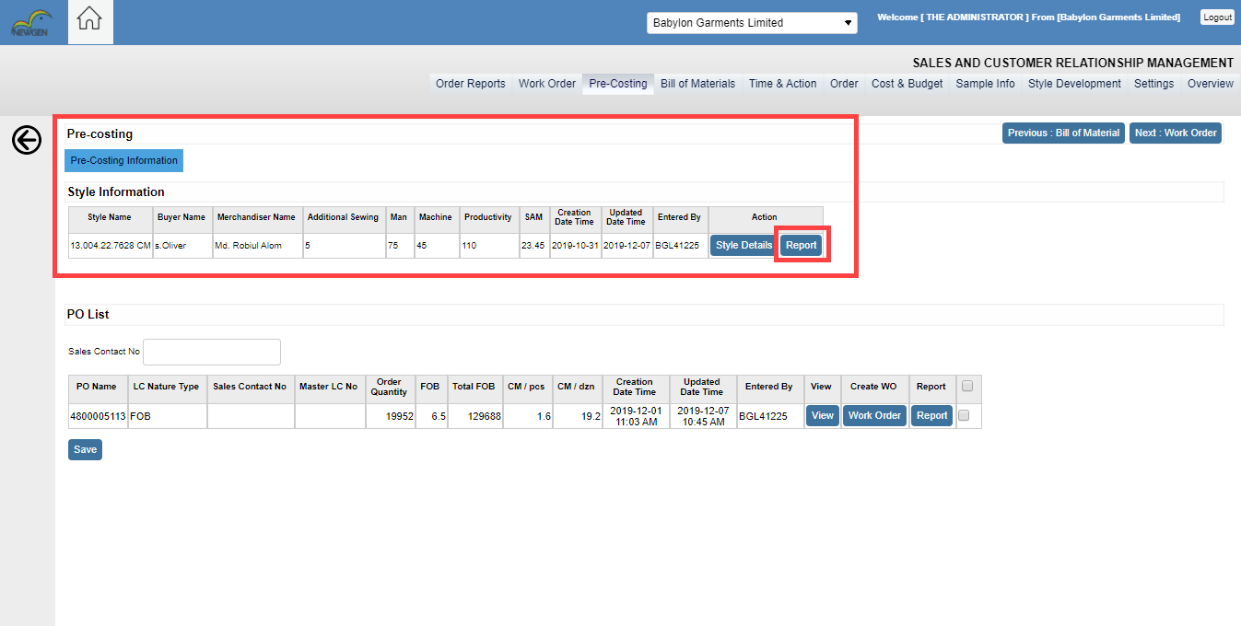

After Completing pre-costing Information then The User has to input sales contact. Selected PO’s added under the provided Sales Contact Number, it will be Placed in Sales Contact No. Then click the save button.

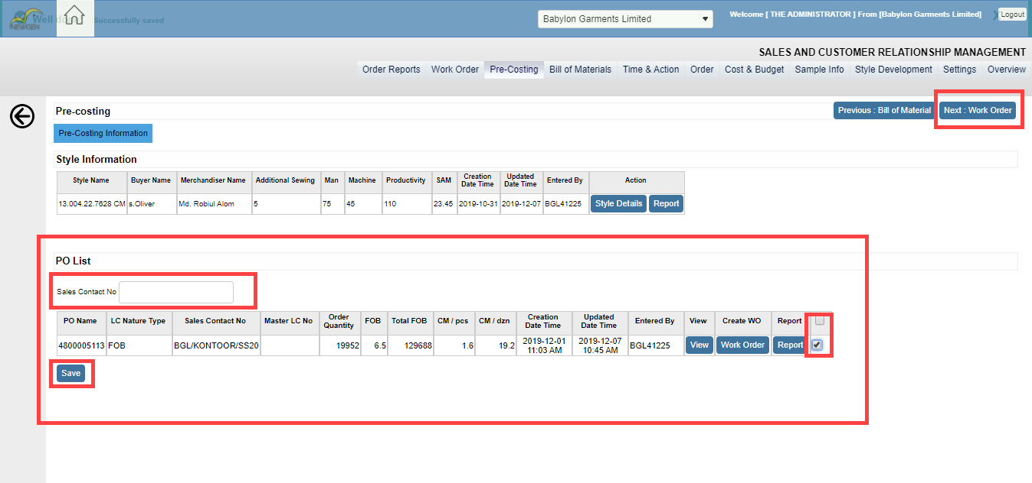

After Completing pre-costing, User click on the next work order process. In the work order menu, the User will get PO List for the work order. users can view the work order list. When the user clicks on the WO List then the list will be shown. Then the user can create PI number and PI date against of work order. The User has to select the checkbox

Selected Work Order number added under the provided PI number will be done by clicking submit button. After creating PI number user has to click on the Create Purchase Order.

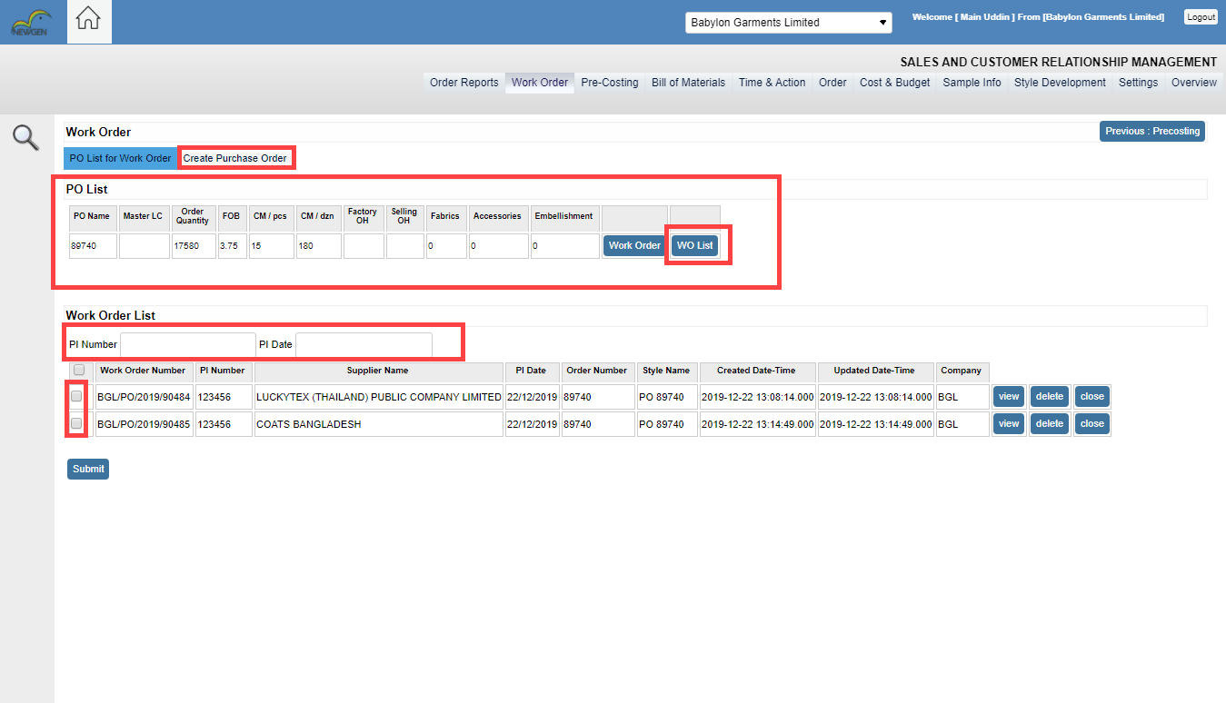

In the part of creating a purchase order, the User has to fill-up the supplier name and others mandatory field. The user will find all other materials name those are included in the BOM sheet and finally fixed the budget for the material and the User can delete or edit the material name with its Consumption and other fields. Users can also add some conditions against an order. After Completing the purchase order user have to click on the Save button. When the user clicks on the save button then randomly system create a Work order number.

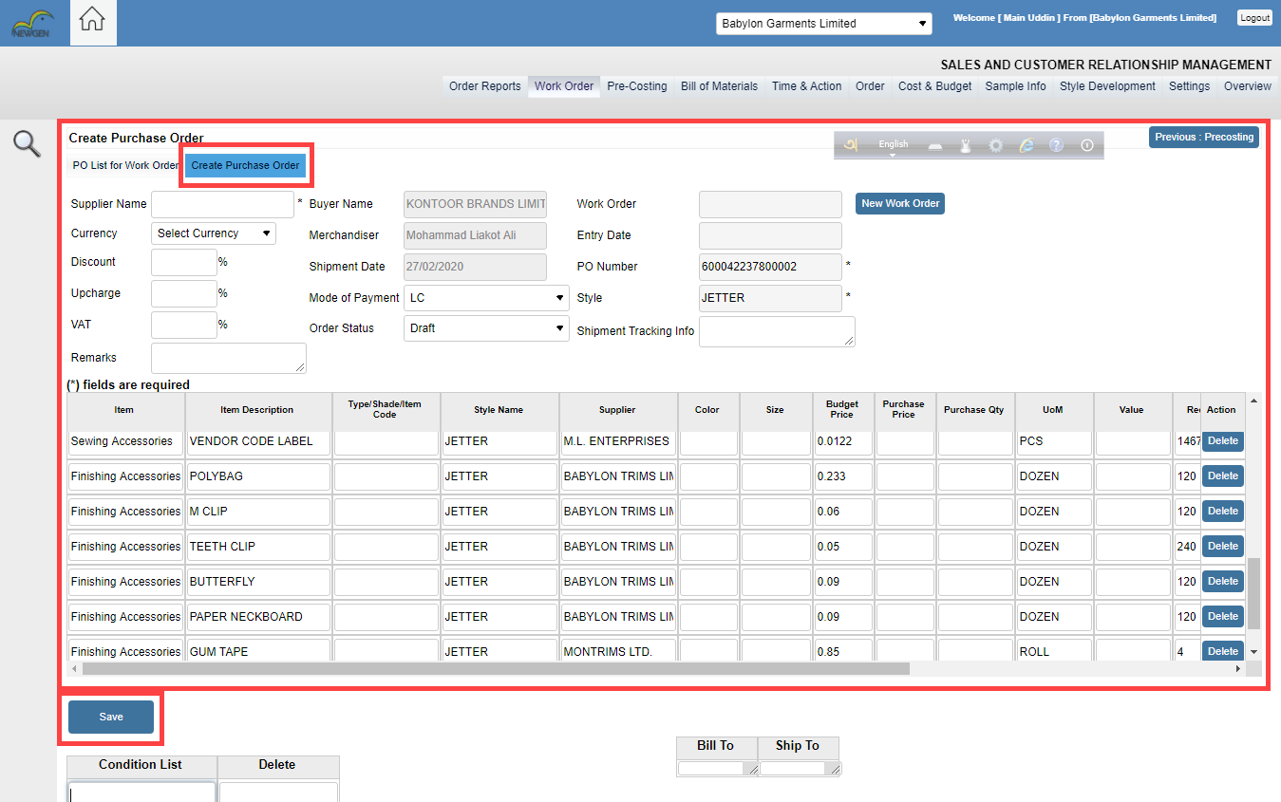

If user wants to purchase multiple product order from supplier, then user have to click on the “+” Icon

And input the supplier name. Then click on the next button.

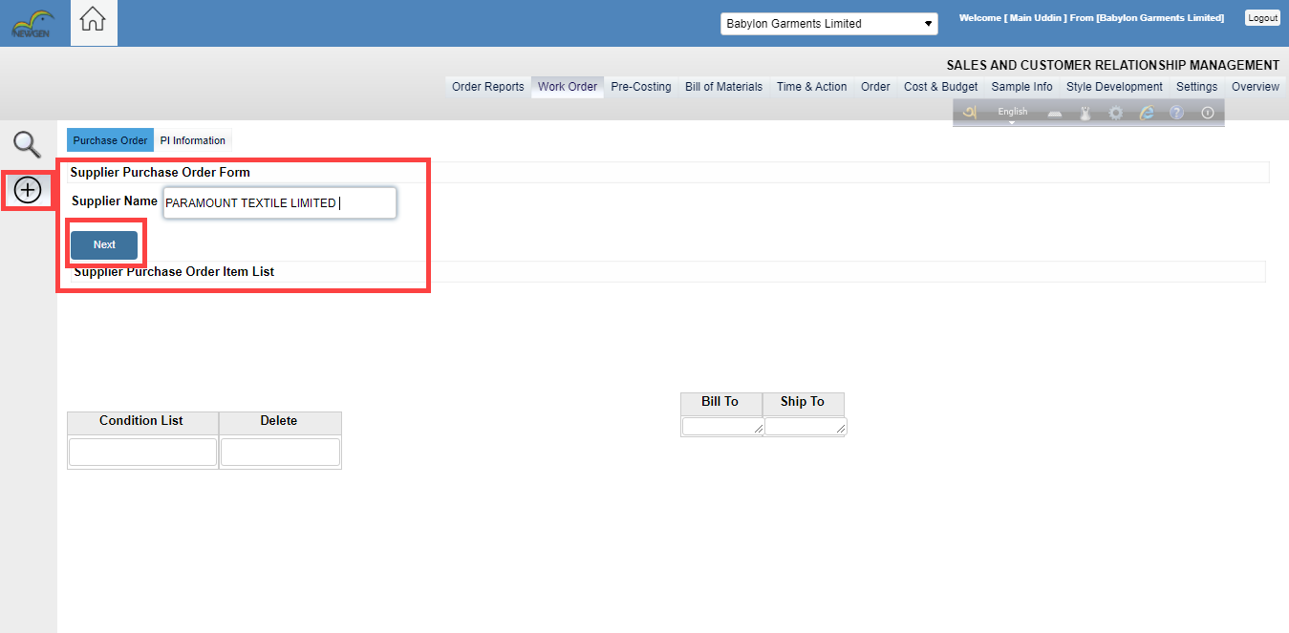 After clicking the next button, users have to click on the select material then user get a screen view where users can select materials then click on the submit button. After selecting material list user can modify supplier purchase order list. Then users need to click on the update button.

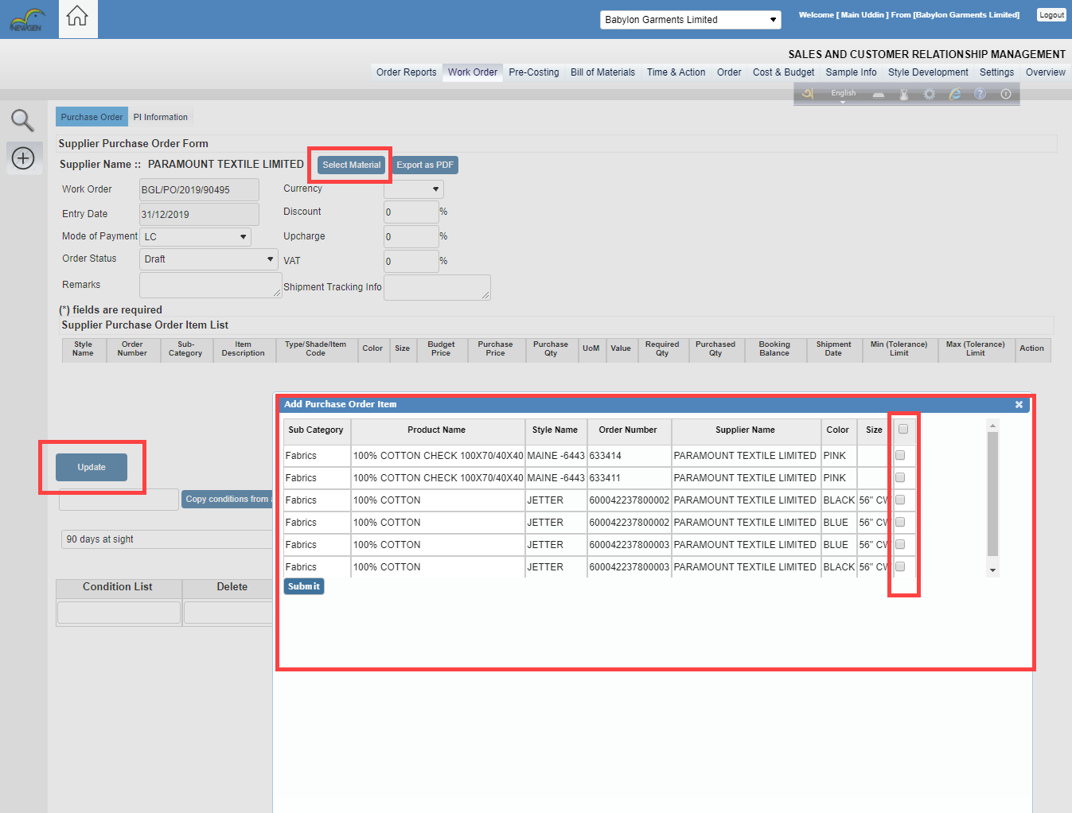

After Creating the purchase order, User can search work order. To search the work order, user have to click on the work order from the menu bar and click the search icon

User can find Multiple style purchase order information by style name, sales order number, work order number, or from date to thru date. Then the list will be shown.

